Compiler Design
Theoretical Question Answer
1. What is a compiler? Explain the main purpose of a compiler in a programming language environment.
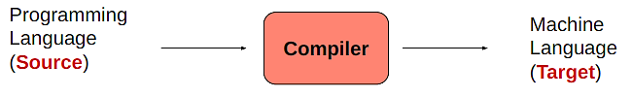
Ans: A compiler is a computer program (or set of programs) that
- Transforms source code written in a programming language
- Is a translator program

The main purpose of a compiler in a programming language environment.
• To design a translator
• Influences on programming language design
• Influences on computer design
• Compiling techniques are useful for software development
─ Parsing techniques are often used
─ Learn practical data structures and algorithms
─ Basis for many tools such as text formatters, structure editors, design verification tools,…
Source Code → Compiler → Object Code / Machine Code → Execution

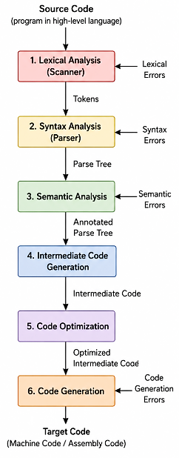
2. Differentiate between a compiler and an interpreter.
Compiler | Interpreter
Translates the whole program at once. | Translates one line at a time.
Generates an executable file. | Does not create an executable file.
Finds errors after compiling the whole program. | Finds errors line by line immediately.
Program execution is faster after compilation. | Program execution is slower because translation happens during running.
Example: C Programming Language, C++ | Example: Python, JavaScript

3. What are the various phases of a compiler? Briefly explain the function of each phase with a proper figure.

Explain the each function:
i. Lexical analysis: Experience with Regular Expressions and will be important when you deal with
- big text files;
- automating routine text processing tasks.
ii. Syntax Analysis: Parsing is important in
- Text and language processing tasks; if you're trying to interpret tweets or sentences, etc.
iii. Semantic Analysis:
- At this stage, actually start to understand the programming languages that use even in our day to day life.
- Understanding various constraints related to assignment, allocation
iv. Intermediate Code Generation:
- Generates middle level code according to the semantics.
- You will learn different platform independent codes
v. Code Optimization:
- introduced to various Optimization techniques in code generation.
- also be more critical of the code write for other works.
vi. Code Generation:
- learn to generate the Machine Code.
- This forces to learn Assembly Language;
- an overview of applying basic Computer Architecture concepts.
4. What is lexical analysis? What is the role of a lexical analyzer in a compiler?
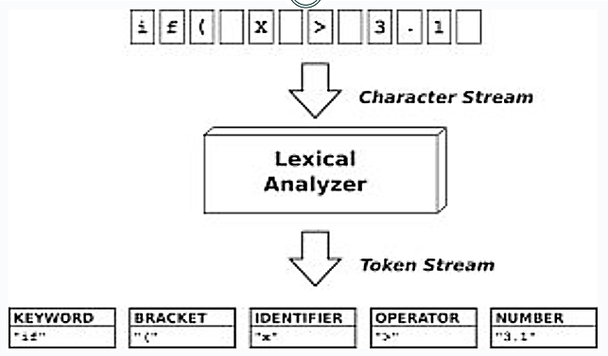
Lexical analysis is the first step in a compiler where the source code is broken into small meaningful parts called tokens (like words, numbers, and symbols).
The role of Lexical analyzer:
- First phase of a compiler
- Main task
- To read the input characters
- To produce a sequence of tokens
- An assistant of parser

5. Define the following terms with examples:
a. Token
b. Lexeme

Ans: a) Token: A token is a small meaningful unit of a program in a programming language. Types of words in source program like Keywords, operators, identifiers, constants, literal strings, punctuation symbols (such as commas, semicolons).
Example:
- Keywords: int, if, return
- Identifiers: sum, x, total
- Operators: +, -, =
- Symbols: ;, (), {}
- Numbers: 10, 25

b) Lexeme: Actual words in source program matched by pattern. It’s a valid token.
Example: int, sum, = , 10
6. What is syntax analysis (parsing)? Why is it important in the compilation process?
Syntax Analyzer creates the syntactic structure of the given source program. This syntactic structure is mostly a parse tree.
The syntax of a programming is described by a context-free grammar (CFG) or BNF (Backus-Naur Form) notation.

Why it is important:
- Checks program structure
- Finds syntax errors
- Builds parse tree
- Helps later phases

7. What is context-free grammar (CFG)? Explain the different components of a CFG with an example.
A Context-free Grammar (CFG) is utilized to describe the Syntactic Structure of a Language.

Components of CFG: A CFG is written as a 4 tuple like that G = T, N, P, S

1. Terminals(T): These are the actual symbols of the language. They cannot be broken further.
Example: id, +, -, *, /, (, )
2. Non-terminals / Variables (N/V): These are symbols that can be replaced further. They help define structure.
Example: expr, op
3. Productions(P): These are the rules used to replace variables.
Example: expr → expr op expr, expr → ( expr ), expr → - expr, expr → id, op → + | - | * | /
4. Start Symbol(S): The starting point of the grammar. Usually represented by S.
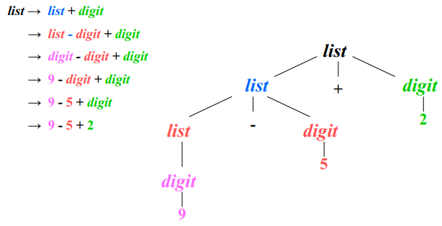
Example: expr
8. What is the purpose of a parse tree?
- Checks syntax correctness
- Shows program structure
- Helps detect syntax errors
- Helps semantic analysis
- Supports code generation
9. Define Ambiguity in CFG with proper examples.
A grammar produces more than one parse tree for a sentence is called as an ambiguous grammar. A CFG is ambiguous if one string can have more than one parse tree.

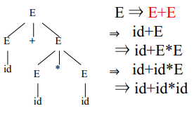
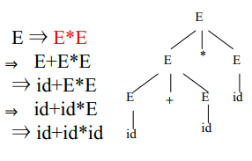
Example:
E → E + E | E – E | E * E | E / E | - E
E → ( E )
E → id

Technical Questions
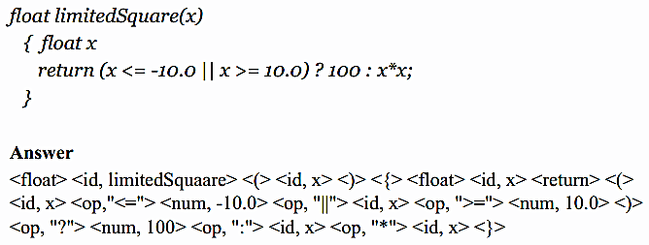
1. Given a piece of code and the CFG, divide the program into appropriate lexeme. Slide-2, Page: 27-32
i.

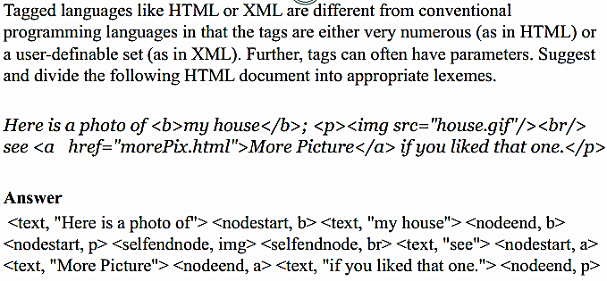
ii.

2. Write the regular expressions for matching given types of strings. Slide-2, Page: 14-26
String Matching: i. Username RegEx, ii. Password RegEx, iii. Email Address RegEx, iv. Validate Date
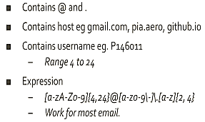
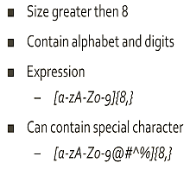
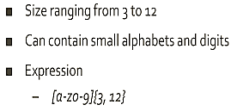
i. Username RegEx: ii. Password RegEX: iii. Email Address RegEx:

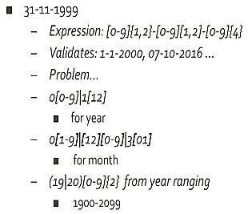
iv. Valid Date RegEx:

3. Given a CFG, check if ambiguous. Slide-3, Page: 18-24
Ambiguous: E → E + E | E – E | E * E | E / E | - E
E → ( E )
E → id
Case 1: (id + id) * id Case 2: id + (id*id)
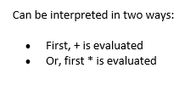
In this grammar:
- There is no precedence rule for + and *
- The same expression can be grouped in different ways
- Therefore, multiple parse trees can be formed

This CFG is Ambiguous, because for the same string.

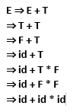
Unambiguous : E → E + T | T
T → T * F | F
F → id case : id + id * id
In this grammar:
✔ * has higher priority than +
✔ Fixed grammar rules decide structure
✔ Only one valid parse tree exists for each string

This CFG is Unambiguous because every valid string has only one unique parse tree and derivation.

End

Slide – 02
Page 27-32
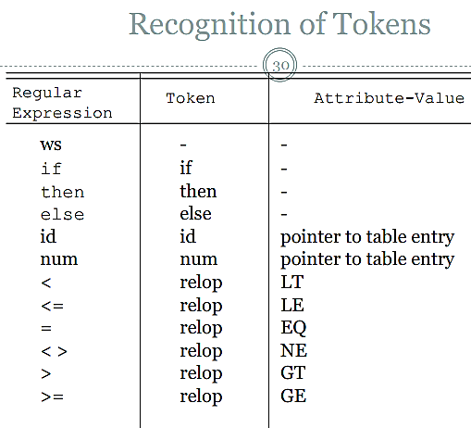
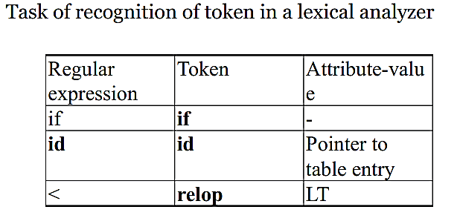
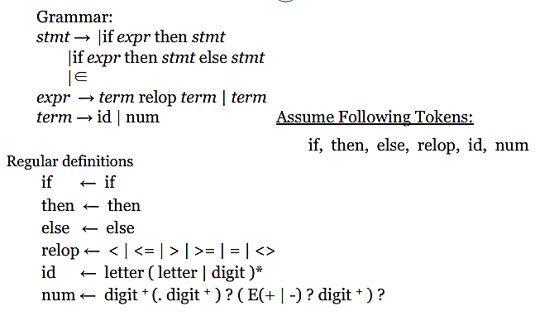

Slide – 03
Page 18-24
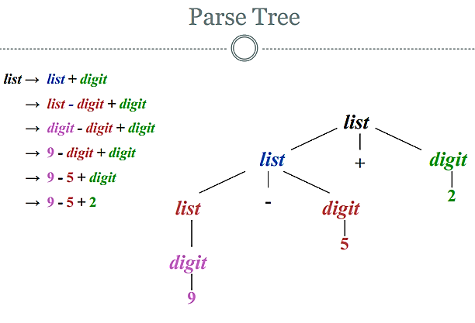

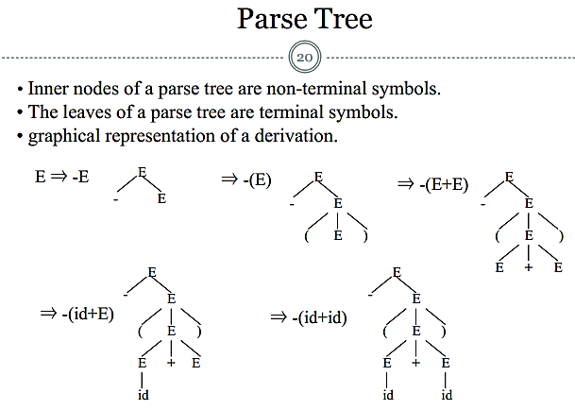
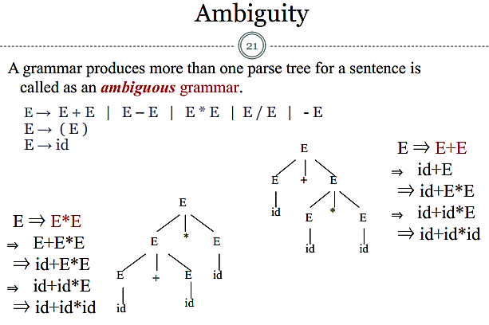
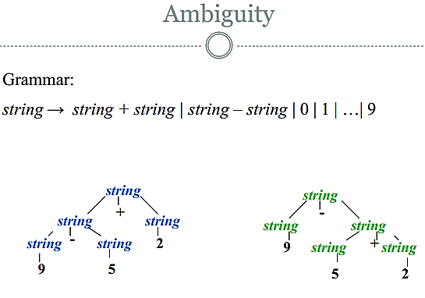

Final Term
Descriptive
1. Compiler
Ans: mid 1, 2, 3
2. Lexical Analyzer
i. Working Process: mid 4
ii. Different Component of Lexical Analyzer.
Ans: A Lexical Analyzer is the first phase of a compiler. It reads the source code character by character and converts it
into tokens.
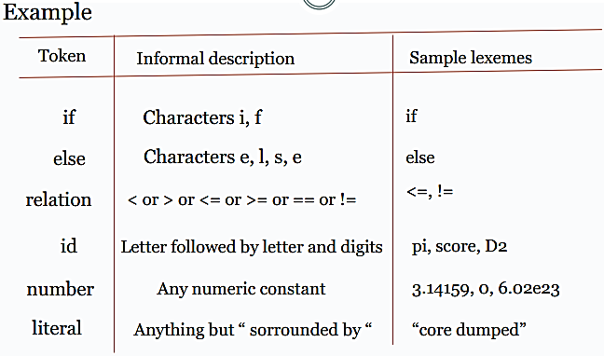
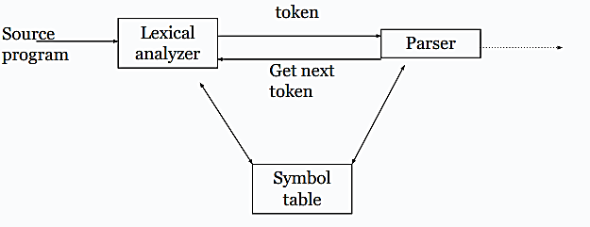

Main Component:
- Scanning:
i. Pre-Processing
ii. Correlating error messages from compiler with source program
iii. A line number can be associated with an error message
- Lexical Analysis
- Token
Keywords, operators, identifiers, constants, literal strings, punctuation symbols (such as
commas, semicolons)
- Lexeme
i. Actual words in source program matched by pattern
ii. valid token
- Pattern
i. A rule describing the set of lexemes that can represent a particular token in source program
ii. Relation {<, <=, >, >=, ==, <>}

iii. Define the Token.
Ans: mid question 5

3. Syntax Analysis
i. Define Syntax Analysis. Ans: mid 6.
ii. Grammars: CFG
iii. Trees:
a) Define Parse Trees with diagram.
Ans: A parse tree pictorially shows how the start symbol of a grammar derives a string in the language.
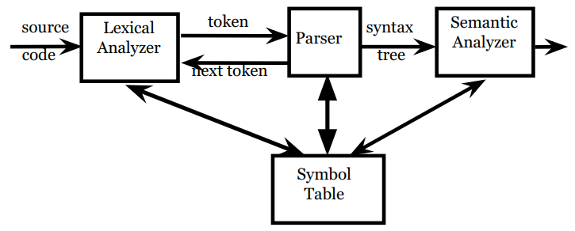

Figure: Parse Tree
b) More Formally, a Parse Tree for a CFG Has the Following Properties:
⚪ Root Is Labeled with the Start Symbol
⚪ Leaf Node Is a Token or ∈
⚪ Interior Node Is a Non-Terminal
⚪ If A → x1x2…xn, Then A Is an Interior; x1x2…xn are Children of A and May be Non-Terminals or Tokens

c) Write the purpose of Parse tree.
Ans: mid 8.
iv. Ambiguity
a) Define Ambiguity in CFG with proper examples.
Ans: mid 9
b) Ambiguity – Operator Precedence
Ans: Ambiguous grammars (because of ambiguous operators) can be disambiguated according to the precedence
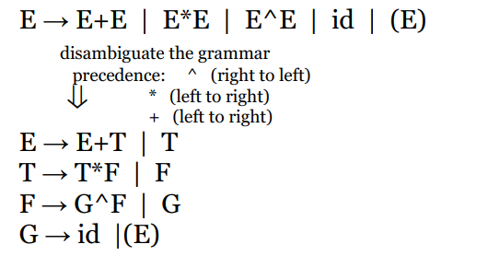
and associativity rules.

4. CFG
i. Definition of CFG(Context Free Grammar? Explain the different components of a CFG with an example.
Ans: mid 7
ii. Context Free Grammar Derivations Step and Example.
Ans: In a context-free grammar, we have:
⚪ A finite set of terminals
⚪ A finite set of non-terminals
⚪ A finite set of production rules of the form
A → α
where A is a non-terminal and α is a string of terminals and non-terminals .
⚪ A start symbol
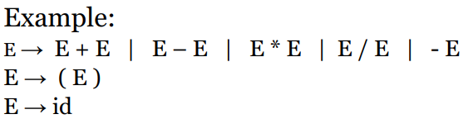
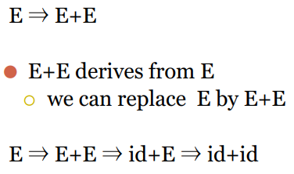
Derivations:

iii. Define Left most derivation with example.
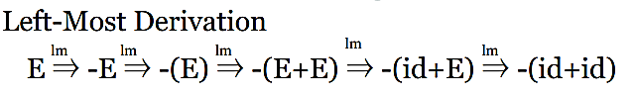
Ans: If we always choose the left-most non-terminal in each derivation step, this derivation is called as left-most derivation.

iv. Define Right most Derivation with example.
Ans: If we always choose the right-most non-terminal in each derivation step, this derivation is called as
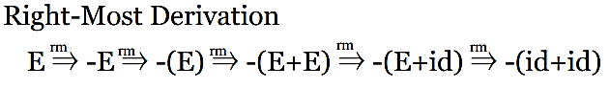
right-most derivation.

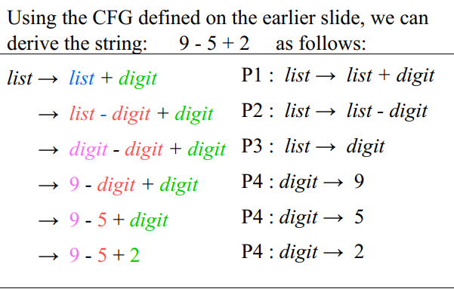
v. Derivation:

5. Intermediate Code
i. Define Intermediate Code .
Ans: The source code of a program is translated into a form called intermediate code. Intermediate Code (IC)
is a machine-independent code generated by the compiler between the source code and machine code.

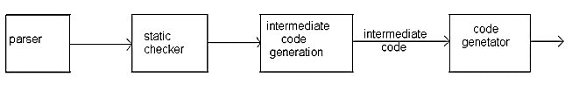

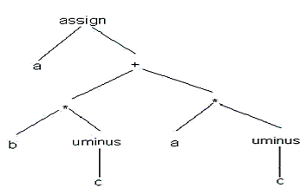
ii. Define Semantic Tree/ Syntax Tree.
Ans: A syntax tree depicts the natural hierarchical structure of a source program.
Ex. A syntax tree for the assignment statement
a:=b*-c+a*-c

iii. Quadruples vs Triples vs Indirect Triples.
Ans:
Feature | Quadruples | Triples | Indirect Triples
Number of fields | 4 | 3 | 3+ pointer table
Format | (op, arg1, arg2, result) | (op, arg1, arg2) | Pointer → Triple
Temporary variables | Required | Not required | Not required
Reference to previous result | Temporary variable | Statement number | Pointer/statement number
Code movement | Easy | Difficult | Easy
Memory requirement | More | Less | More than Triples
Implementation | Simple | Simple | More Complex

Mathematical
1. Generate regular expressions for matching certain string formats.
Ans: mid Technical question 02.
2. Draw transition diagrams for how Regular Expression matches a string.
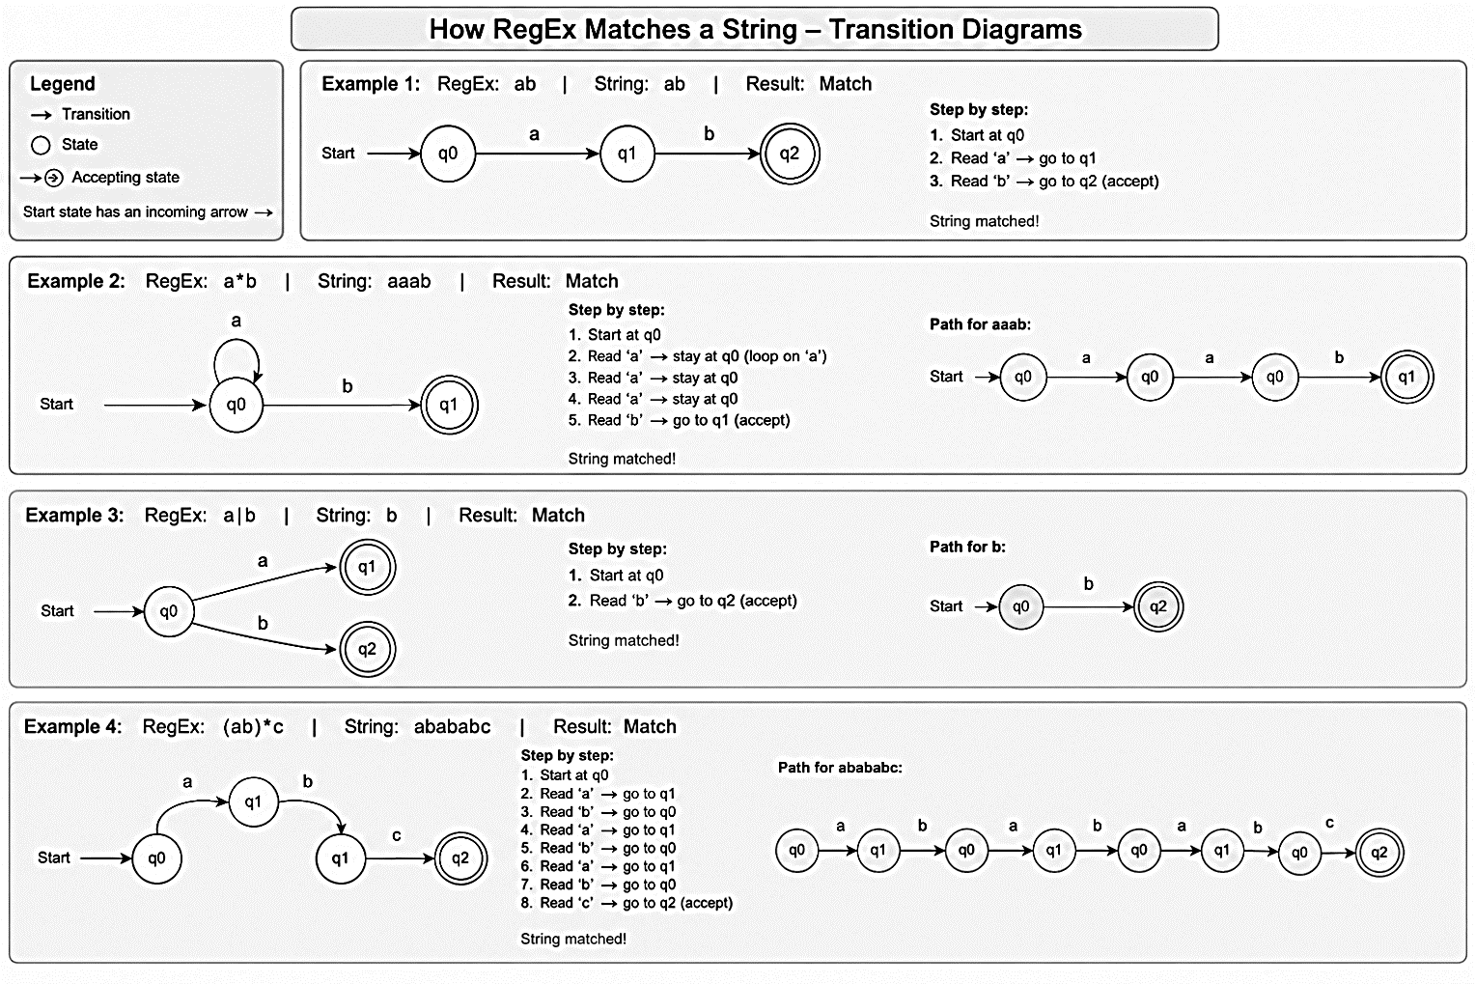
Ans:

A transition diagram contains:
- Circle → a state
- Arrow → transition from one state to another
- Arrow labeled a, b, etc. → the input character that causes the transition
- Double circle → accepting/final state
- Start arrow → starting state
The machine reads the input string one character at a time and follows the corresponding arrows.

3. Check a grammar for ambiguity
Ans: mid technical question 3
4. Eliminate left recursion and left factoring from a given grammar
5. Remove all types of ambiguity from a grammar (remove op ambiguity, remove left recursion, implement left factoring)
Implement Left Factoring:
- A predictive parser (a top-down parser without backtracking) insists that the grammar must be left-factored.
stmt → if expr then stmt else stmt |
if expr then stmt
- when we see if, we cannot know which production rule to choose to re-write stmt in the derivation
- In general, A → αβ1 | αβ2
- when processing α we cannot know whether expand A to αβ1 or A to αβ2
- But, if we re-write the grammar as follows

A → αA ′
A′ → β1 | β2
so, we can immediately expand A to αA ′

6. Generate Three Address Code from statements and represent using quadruples/ triples/ indirect triples.

